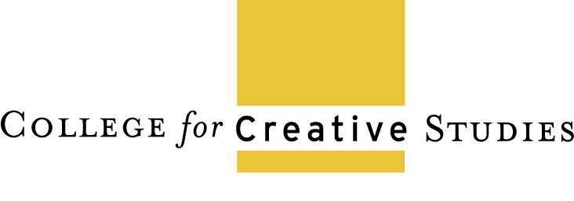

Provost and Vice-President

for Academic Affairs/CAO

The *College for Creative Studies (*www.ccsdetroit.edu/*)*, a nonprofit private college located in Detroit, Michigan, seeks a creative, visionary, and entrepreneurial leader for the position of Provost and Vice-President for Academic Affairs/CAO (Provost/VPAA/CAO). Founded in 1906 when a group of local civic leaders formed the Detroit Society of Arts and Crafts, the College educates visual artists and designers knowledgeable in varied fields, who will be leaders in creative professions that shape society and advance economic growth.  The College, authorized by the Michigan Education Department to grant Bachelor’s and Master’s degrees, fosters students’ resolve to pursue excellence, act ethically, embrace their responsibilities as citizens of diverse local and global communities, and learn throughout their lives.

Reporting to the President from the A. Alfred Taubman Center, the Provost/VPAA/CAO will have an extraordinary opportunity to advance a distinctive college incorporating a range of forward-looking programs in visual arts, media, and design. As the chief academic officer of the College, the Provost/VPAA/CAO is responsible for all matters related to academic operations including oversight of faculty and curriculum and is a catalyst for innovation. In collaboration with the President, leadership team, and faculty, the Provost/VPAA/CAO will implement and evolve the College’s strategic plan to build upon the College’s excellence through program development, faculty professional development, encouragement of greater interdisciplinary learning, integration of new technologies such as AI, and promotion of partnerships with varied outside organizations. The Provost/VPAA/CAO will help to enhance the College’s reputation by serving as a spokesperson for it locally, nationally, and internationally and advocating for the value of art and design to society. **Visit** [**www.Hyatt-Fennell.com**](http://www.Hyatt-Fennell.com) **for more information**.

The College for Creative Studies is being assisted by the partners of Hyatt–Fennell Executive Search. Applications should be submitted to: [**ccsdetroit@hyatt-fennell.com**](mailto:ccsdetroit@hyatt-fennell.com) and should include a letter of interest, a current résumé/cv, and contact information for five professional references. Applications will be reviewed as they are received, and the position will remain open until filled**.** All applications and nominations will be considered highly confidential**.** *The College for Creative Studies is an Equal Opportunity Employer.*



**For more information contact:**

**Cheryl Hyatt or Jann Weitzel**

**724-242-0476**

[**ccsdetroit@hyatt-fennell.com**](mailto:ccsdetroit@hyatt-fennell.com)

**www.HYATT-FENNELL.com**